**Chapter 3-The SRCUM Process**

1. **Initial SCRUM Meeting**

Each week we had a SCRUM meeting, a scrum is an agile process that allows us to focus on delivering the highest business value in the shortest time. Each week of a sprint, we held a weekly scrum meeting which was called the weekly scrum. Our meeting was held every Wednesday in the same location each week. Each meeting lasted approximately 15 minutes. This ensured that the discussion remained relevant and we did not fray of topic. Having the weekly scrum gave each team member the opportunity to show their progress over the course of the week or explain to the other team members any issues they had during the week. One member was assigned the position of the scrum master each week. The job of the scrum master was to ask each team member the three main questions which were:

1. What did you do last week?
2. What do you plan on doing this week?
3. Are there issues or problems in your way?

By the end of each scrum meeting each member was aware of the progress of the other team members as well of the progress of themselves. It gave us the opportunity to solve any issues that may have arose for a member during the week. Each scrum meeting kept us on track for the following week.

Once we chose our group project, the next step was to create a set of user stories. “User stories are short, simple descriptions of a feature told from the perspective of the person who desires the new capability, usually a user or customer of the system” (Mountain Goat Software, 2017). Each member of the team created these user stories individually. We had our first scrum meeting a week after we had chosen our project idea. As this was our first scrum meeting it lasted for approximately three hours. At our initial scrum meeting each user presented the set of user stories they created over the week. This bought to the table many different ideas that could be included into the project. We discussed each of these functionalities and how it would be possible to implement them into the project. By the end of the first hour we agreed on a set of user stories to which we would follow when implementing our project. Each member was aware of the set of functionalities that we hoped to include in our project. Using our set of user stories, we created a shared story map. Story mapping is an approach to organize and prioritize user stories. Our activities from our user stories were arranged from left to right in the order they would be implemented in our project. We then added task-centric stories under each activity which explained what would be typically done under each activity and in order of which one would be done first. Each activity had multiple task-centric stories since each activity could do more than one task. The story map helped us gain a better understanding of the end-to-end use of the system. It was easier to visualize how many user interfaces we would need and the order in which the would be required. Creating the story map gave us a starting point and a guideline of each tasks we had to implement for each activity.

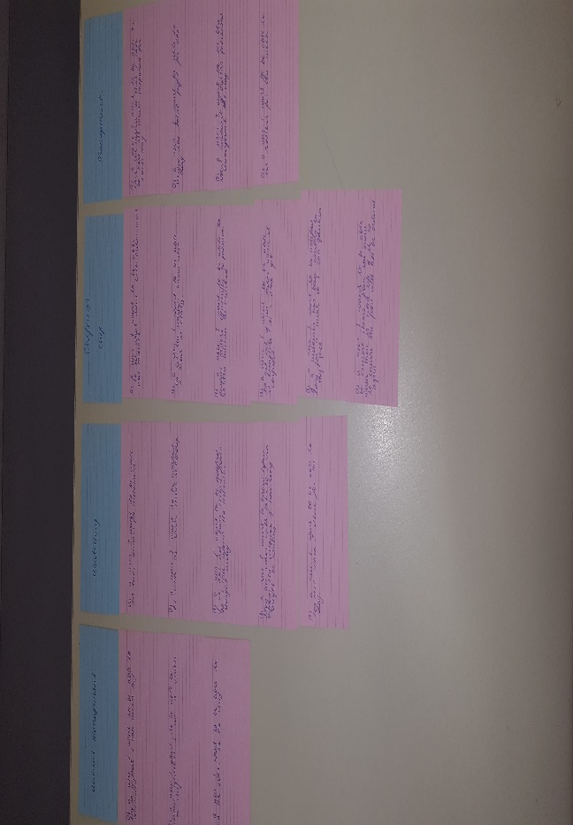

Figure 1: Story Map

1. **Planning Poker**

Once we knew the tasks that need be complete we had to estimate how long each task would take. Each task duration was measured in hours. To estimate the length of time each task would take we used planning poker. “Planning poker is an agile estimating and planning technique that is consensus based.” (Mountain Gate, 2017). Each team member has a deck of planning pokers cards like the one shown in Figure 2, with values 0, 1, 2, 3, 4, 8, 13, 20, 40, 100. The values represented the number of hours in which each team members thought it would take to complete each task. One team member read out each task from our story map, within the team we discussed the features of each task in detail and ensured that we all understood the full functionality of each task. We privately selected one card to represent roughly how long we believed each task would take and then all the chosen cards were revealed at the same time. If we all selected the same value, then that value became the estimate. If not, then we discuss our estimate and why we chose it. Once we got an insight has to why everyone chose the value they did we reselected a new value and again revealed it at the same time. This process was repeated until we came to an agreed estimate for each task. Planning Poker was an easy and fair way to estimate the time required for each task. By using planning poker each member of the team got to have an opinion on each estimate which led to more accurate and realistic estimates.

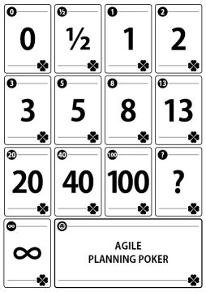

Figure 2: Planning Poker Cards

1. **Meeting Minutes**

During each of our weekly meeting we kept a record of what we talked about during each meeting. This was called the meeting minutes. During each scrum meeting one member of a team was assigned to keep a record of what each meeting consisted of. This person was rotated every week. It was important to keep a record of each meeting. At the start of each meeting the minutes of the previous meeting would be read out. This reminded us of what we talked about the previous week. From keeping account of each meeting, we were able to follow up on any issues that were had the previous week and see if they were resolved over the week. We had a total of ten meeting during the process of the project. A summary of the minutes for each of these meeting was as follows:

Meeting 1: 04/10/2017 This was our first meeting after we chose our project proposal. The aim of this meeting was to ensure that we all knew the purpose of the project, the functionalities to be included in the project and an estimate of the time it would take us to complete the project. We used user stories, story maps and planning poker for this meeting. By the end of this meeting we all knew the complete objective of our project and an estimate of how long we wanted to spend on each task that need to be implemented.

Meeting 2: 11/10/2017 Before we started out this meeting we began by reading out the minutes of the previous. We ensured that we were all up to date on the progress of our project. Since we knew all the functionalities our application required, we began dividing each task between all the team members. Since the application required five user interfaces and there was five team members we decided to give one UI to each member. We aimed to start building each UI for the following week.

Meeting 3: 18/10/2017 Once again we started our meeting by reading the minutes of the previous meeting. At this meeting each member showed the progress they had made to each the other members of the team. Each member presented the work they had done to all the other team members. A start had been made on all the UI’s, but no functionality had been added. Each student had a guideline of how each page was going to work and where each functionality would be. During this meeting we made sure that everyone was happy with each UI and if any changes needed to be made before implementing the functionalities for the application.

Meeting 4: 25/10/2017 Due to lack of communication over the previous week, there was not much progress this week. Over the week it was thought that we all had to work on the same UI so at this meeting everyone had focused on working a single UI and therefore only one user interface was worked on. Due to this at this meeting we decided that we needed to communicate better both in person and through telegram, so we decided that as well as the weekly meetings we would meet up for an extra hour later in the week. This was to ensure that everyone was up to date and so that if there was any changes or issues we could try to resolve them before the next weekly meeting.

Meeting 5: 8/11/2017 For this week each member of the team had to present the work they had done over reading week to all the other members of the team. A good start on implementing the functionalities had been made on most of the UI’s. We discussed the problems that were in our way. One of the major problem was that most of us did not have the general idea of how firebase worked. “Firebase is Google’s mobile platform that helps you quickly develop high-quality apps and grow your business” (Firebase, 2017). Four of the UI’s required firebase due to authentication and putting information into and pulling information from the database. At this meeting we decided that we would all take the week to gain a better understanding of how firebase worked so that we would be able to implement it into our application. Another major problem was that one of the team members laptop had broke over the week therefore loosing all the work they had done over the week. This meant that we were behind on one of the UI, to solve this problem we met up later in the week and as a team we worked on this UI bringing it up to date with all the other UI’s.

Meeting 6: 15/11/2017 By this meeting most of the team had a better understanding of how firebase worked. We began to add firebase to our application. Some team members had issues trying to implement firebase, so we worked on trying to fix these issues. We decided that we would continue to focus on completing the functionality of the app before looking at the design of the application.

Meeting 7: 22/12/2017 At this meeting we decide to start looking at how we were going to style our application. We collectively agreed on a set style that each UI would have and planned to have included in each UI for the when we met up later in the week. At this point we were on track with our project, but we did decide that we needed to start thinking about hosting and looking at the group report in more detail.

Meeting 8: 29/11/2017 -Last Week of Development At this meeting all the functionalities had been added to each UI and there was a set style on each UI. Each member displayed there working UI’s to the other team members. We made sure each user interface worked as how we expected it to by going back to our story map and looking at the tasks we had planned to include in our final project. We also decided we would meet up later in the week to start looking at hosting.

Meeting 9: 6/12/2017 By this week we had our application hosted. Our application was complete, and we began to practice for our presentation. We made sure we were all sure of what part of the application we were talking about. Whilst preparing for our presentation we decided to also record our screencast while we were all together. We decided that we would meet up at the beginning of the following week just to have a run through the presentation. This was our last weekly meeting.

Meeting 10: We decided to meet up one last time during the week. For this meeting we just focused on talking about the report. As we were going on our midterm break we just made sure everyone was sure of which parts of the group report they were doing. We set a deadline for when to have the group chapters done by so that the other team members could have it included in their project on time.

**Reference List**

Firebase (2017) [online] Available at: <https://firebase.google.com> (Accessed on 18th of December 2017)

Mountain Goat Software (2017) *User Stories* [online] Available at: [https://www.mountaingoatsoftware.com/agile](https://www.mountaingoatsoftware.com/agile/user-stories) (Accessed on 18th of December 2017)